$$Convolution Neural Network (CNN)$$

$$CNN=Convolution+Neural Network$$
$$Neural Network part we know that$$

$$Neural Network$$
- $layers :input ,hidden,output$
- $neurons:how many neurons$
- $activation functions: which activation function which layer$
- $Parameters cal :Grdaient descent$
- $You need to think about how to avoid the overfit$
- $You need to think about optimizationn$
- $How many batches, how many epochs,$
- $which metrics :cross entropy$
- $intilaizers$

$$Now we will concentrate on Convolution part$$

$$CNN is used for Object detection, Image or Video detection$$
$$CNN very famous===So many developments are based on CNN only$$

$$Why CNN$$
$$Imagine we have an image with size 1000*1000 (Gray Imgage)$$
$$If it is a color image: RGB , the image size is :1000*1000*3$$

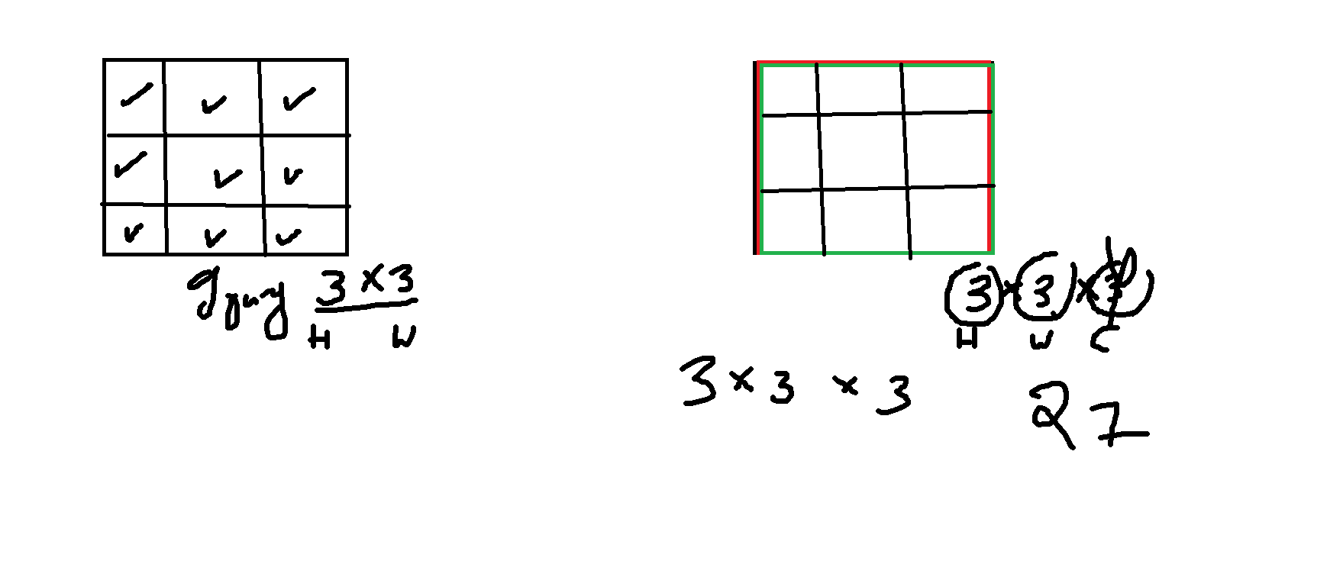

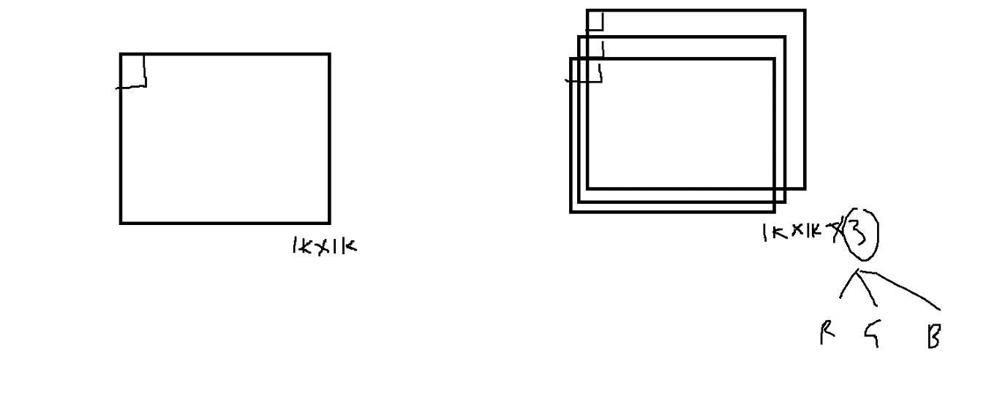

- $For this shape:1000*1000*3 , the number of input layer neurons required is 3M$
- $after this if you give one hidden layer with 1000 neurons$
- $How many parameters=3M*1000+1000≅3B$
- $3B parameters in that starting Input+Hidden layer , to process this we required$
- $so much big compute engines , practically It is not a good idea$

$$why we need pass entire image , why can^{'}t we pass important features$$

$$Idea: Convert Bigger image to small image which is having importnat features$$
$$this image will pass to the Neural network$$

$$Q2) How we get this smaller image from the bigger image$$
$$Convolution: Multiplying two Signals==== > prodce the another signals$$
$$we multiply one image with another image==== > feature map$$
$$Original image * filter or kernal=feature map$$

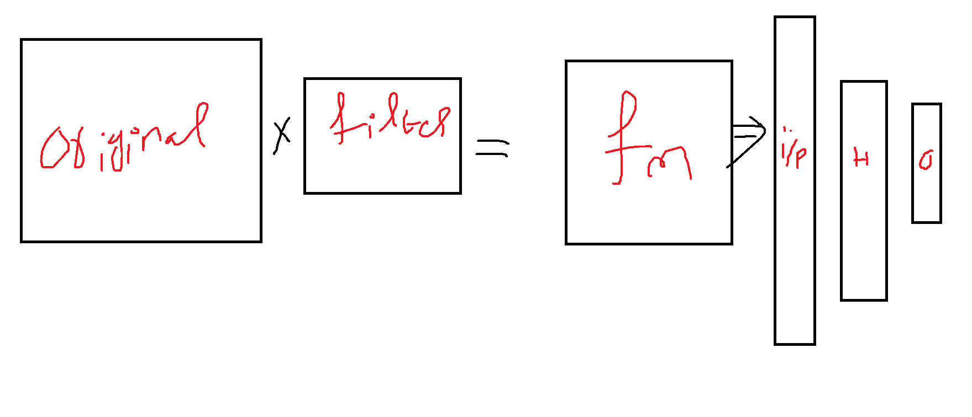

$$filters$$
$$Already existed kernels or filters$$
- $sobel filter:used to detect the vertical or horizontal edges$
- $Laplacian filter:used to detect all types of edges$
- $Gaussina blur:To avoid blurr ness and niose$

$$Filters in CNN:$$
- $in CNN filter means weights$
- $these weights will find during the training by using Back prpogation$
- $good weights leads to good filter leads to good feature map$

$$Q3) How to choose the filter :$$
$$In NN filter is nothing but weight matrix$$
$$your weight matrix is good, it will multiply with original image===good features$$

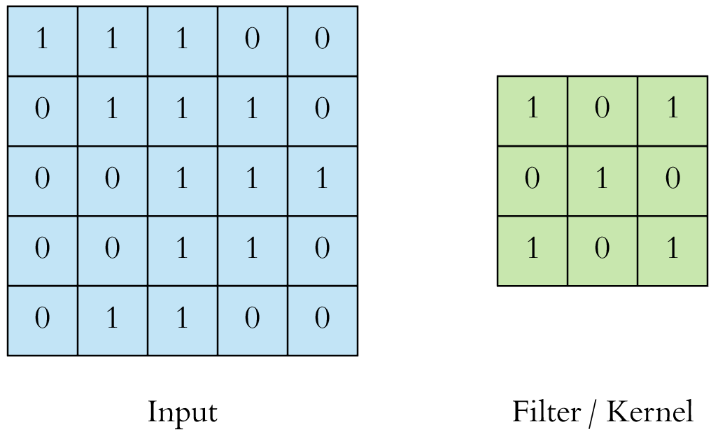

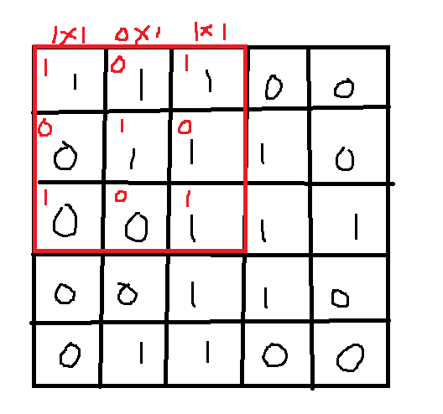

$$1*1+0*1+1*1+0*0+1*1+0*1+1*0+0*0+1*1=4$$

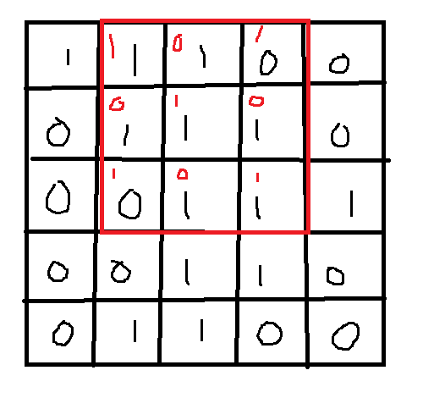

$$1*1+0*1+1*0+0*1+1*1+0*1+1*0+0*1+1*1=3$$

$$First slide to the right side=(4,3,4)$$
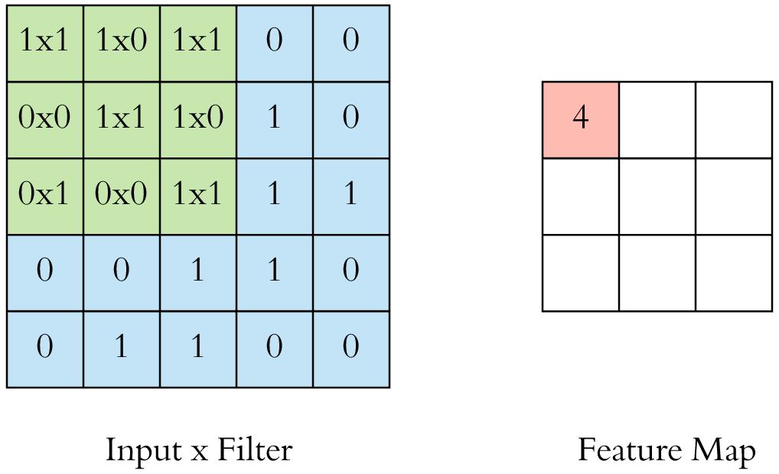

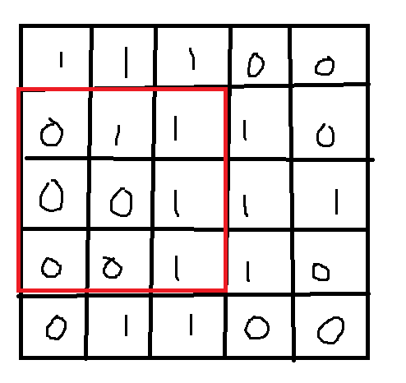
$$First slide to the right side=(4,3,4)$$
$$second slide to the right side=(2,4,3)$$
$$Third slide to the right side=(2,3,4)$$

$$We are multiplying Original image with filter , we are getting feature map$$
4 | 3 | 4
2 | 4 | 3
2 | 3 | 4

$$Original image size 5*5, Filter size is 3*3= Feature map 3*3$$
$$Original image size 6*6, Filter size is 3*3= Feature map 4*4$$
$$Original image size 7*7, Filter size is 3*3= Feature map 5*5$$
$$Original image size N*N, Filter size is F*F= Feature map N-F+1 *N-F+1$$

$$Color image Convolve with filter$$
- $color image means 3 chanels RGB$
- $Example gray imag shape : 5*5$
- $Color image shape :5*5*3$
- $they will mention filter size=4*4$
- $but when we multiply with color image, the filter shape adjusted automatically$
- $so the shape become 4*4*3$
- $original image layer multiply with filter layer$
- $the corresponding layer numbers will be add up$

$$Original image size 5*5*3, Filter size is 3*3*3= Feature map 3*3$$
$$Original image size 8*8*3, Filter size is 4*4*3= Feature map 5*5$$

$$Original image with multiple filters$$
$$original image can be multiply with many filters$$
$$5*5 3*3=3*3$$
$$if we have 10 filters the resultant feature map becomes=773*10$$
$Type equation here.$

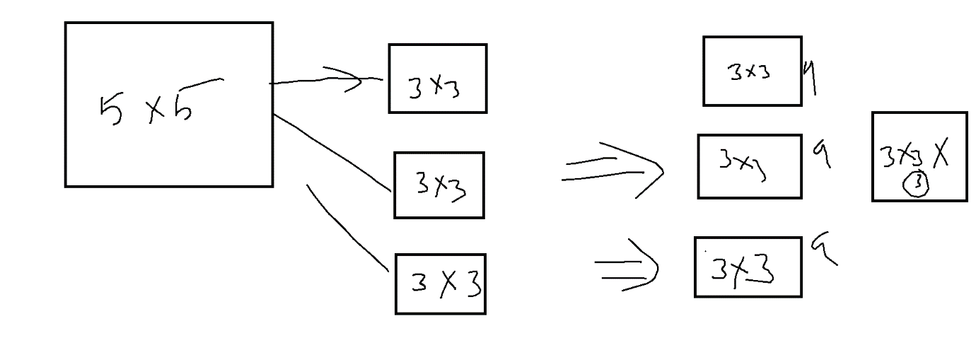

$$Original image size 5*5, Filter size is 3*3= Feature map 3*3$$
$Filter size is 3*3=Feature map 3*3$
$Filter size is 3*3=Feature map 3*3$

case-1: image gray * filter===== >
8x8 3x3 6x6

case-2: image color * filter === >
8x8x3 3x3x3 6x6

case-3: image(8x8) * f1(3x3) 6x6
* f2(3x3) 6x6 6x6x4
* f3(3x3) 6x6
* f4(3x3) 6x6

case-4: image(8x8x3) * f1(3x3x3) 6x6
* f2(3x3x3) 6x6 6x6x4
* f3(3x3x3) 6x6
* f4(3x3x3) 6x6

$$Draw back-1$$
$$Original image size 6*6, Filter size is 3*3= FMap:4*4$$
$$Original image size 6*6, Filter size is 4*4= Fmap:3*3$$
$$Original image size 6*6, Filter size is 5*5= Fmap:2*2$$
$$As filter size increases , resultant image \left(feature map\right)size is decreasing$$
$$which means number of pixels are decreasing , Input becomes less$$
$$Less input data is not good$$

$$CNN: Instead of sending total image, we will multiply a filter and$$
$$we will send a small image which is having importnat features$$

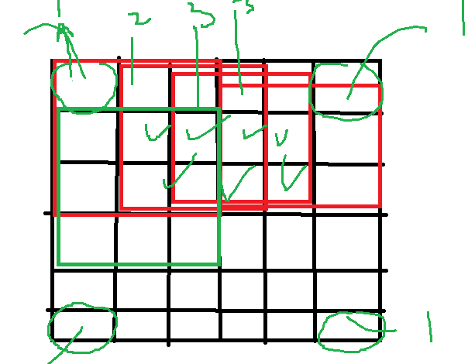

$$Draw back-2: while comvolution edges are calucaulted only one time$$
$with this way we might loss the information$

$$Goal:$$
$we need to avoid image shrink$
$$we need to avoid loss of edges information$$

$$Padding: Adding an extra layers$$
$$\left(6X6\right)*\left(3X3\right)=4*4$$

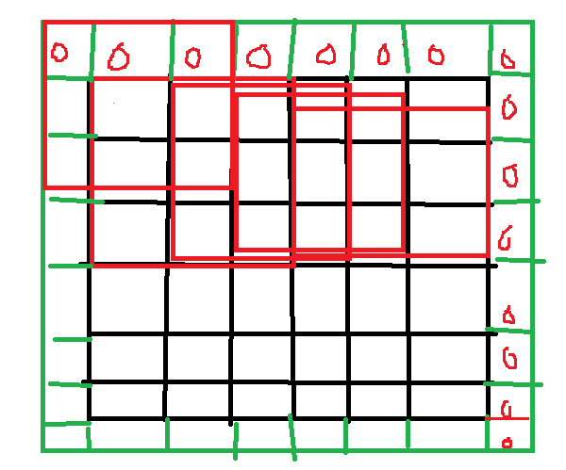

$$Origanal :\left(6X6\right)*\left(3X3\right)=4*4$$
$$padding=1$$

$$\left(6X6\right)*\left(3X3\right) Padding=1 : 6*6$$
$$6*6 becomes 8*8 when we apply padding=1$$
$$N=6*6 , f=3*3 p=1 :$$

$$\left(6X6\right)*\left(3X3\right) Padding=2:$$
$$6*6 becomes 10*10 when we apply padding=2$$
$$N+\left(2p\right)-F+1$$

Original Image | Filter | Padding | Feature map
N*N | f*f | No | (N-f+1)*(N-f+1)
N*N | f*f | Yes =P | (N+2p-f+1)*(N+2p-f+1)

$$Stride:$$
$$To speed up the computaion process , the filter convolve with original image$$
$$which means sliding will skip by one step$$
$$stride is means step size$$
$$by default stride \left(s\right)=1$$
Feature map
Filter
Original image
X =
S oror P

$$Image$$ | $$Stride$$ | $$padding$$ | $$Filter$$ | $$Feaure map$$ | $$Formula$$
$$8*8$$ | $$1$$ | $$0$$ | $$3*3$$ | $$6*6$$ | $$\frac{n+2p-f+1}{s}$$
$$8*8$$ | $$1$$ | $$1$$ | $$3*3$$ | $$8*8$$ | $$\frac{n+2p-f+1}{s}$$
$$8*8$$ | $$2$$ | $$0$$ | $$3*3$$ | $$3*3$$ | $$\frac{n+2p-f+1}{s}$$

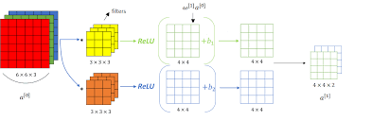

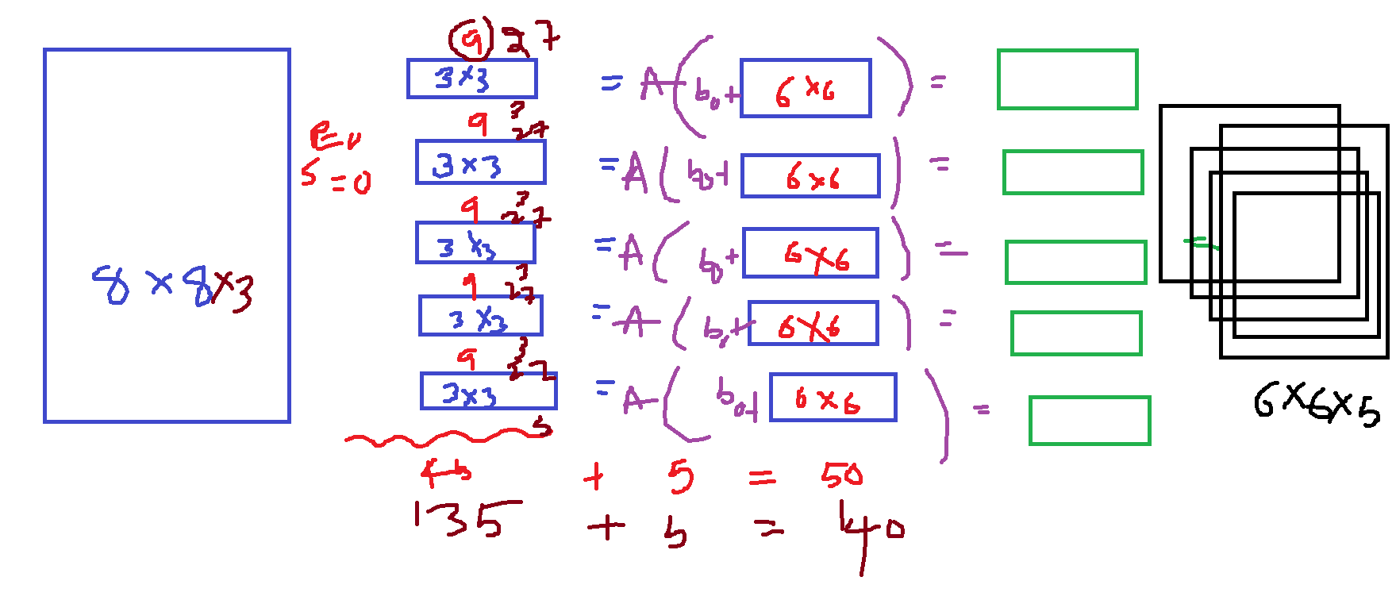
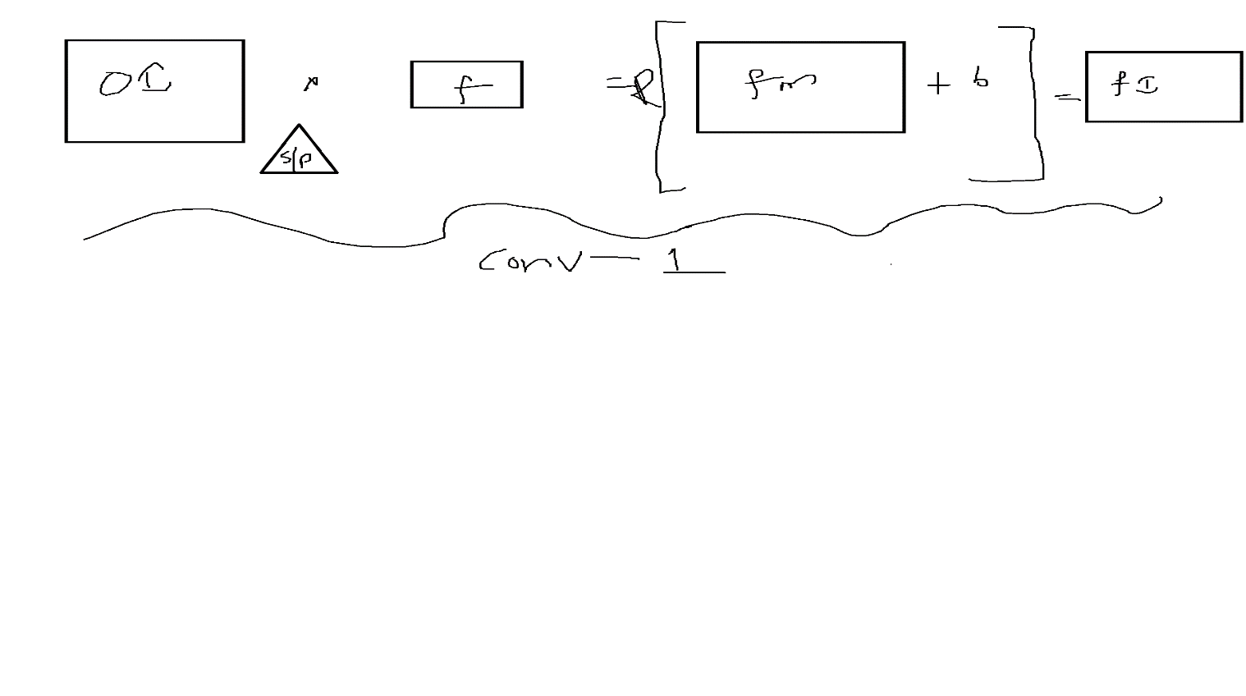

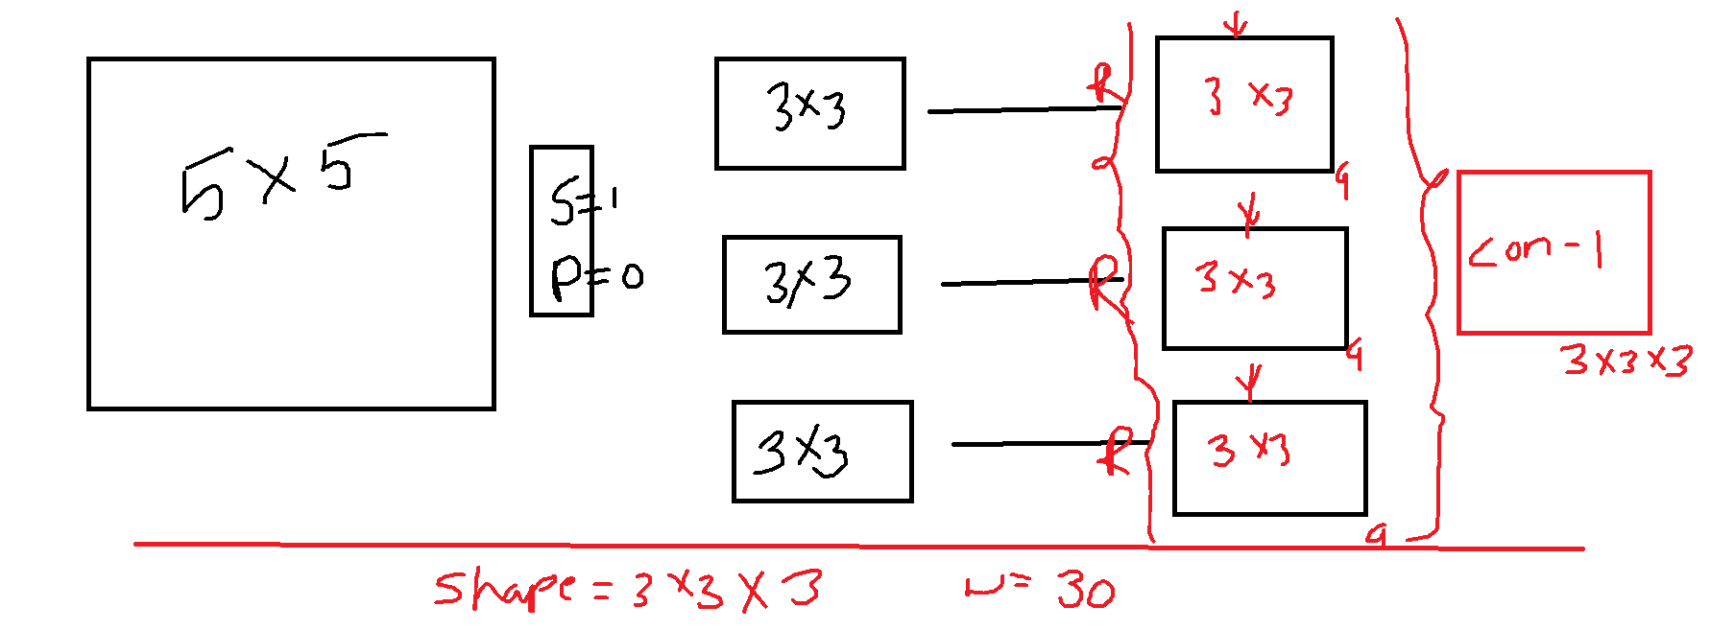

$$\left(6*6 \right) \left(3*3\right)=\left(4*4\right)$$
$$\left(6*6*3\right)\left(3*3*3\right)=(4*4)$$

$$Original image is 6*6*3 , Filter size=3*3*3 Number of filter=2$$
$$Feature map:$$

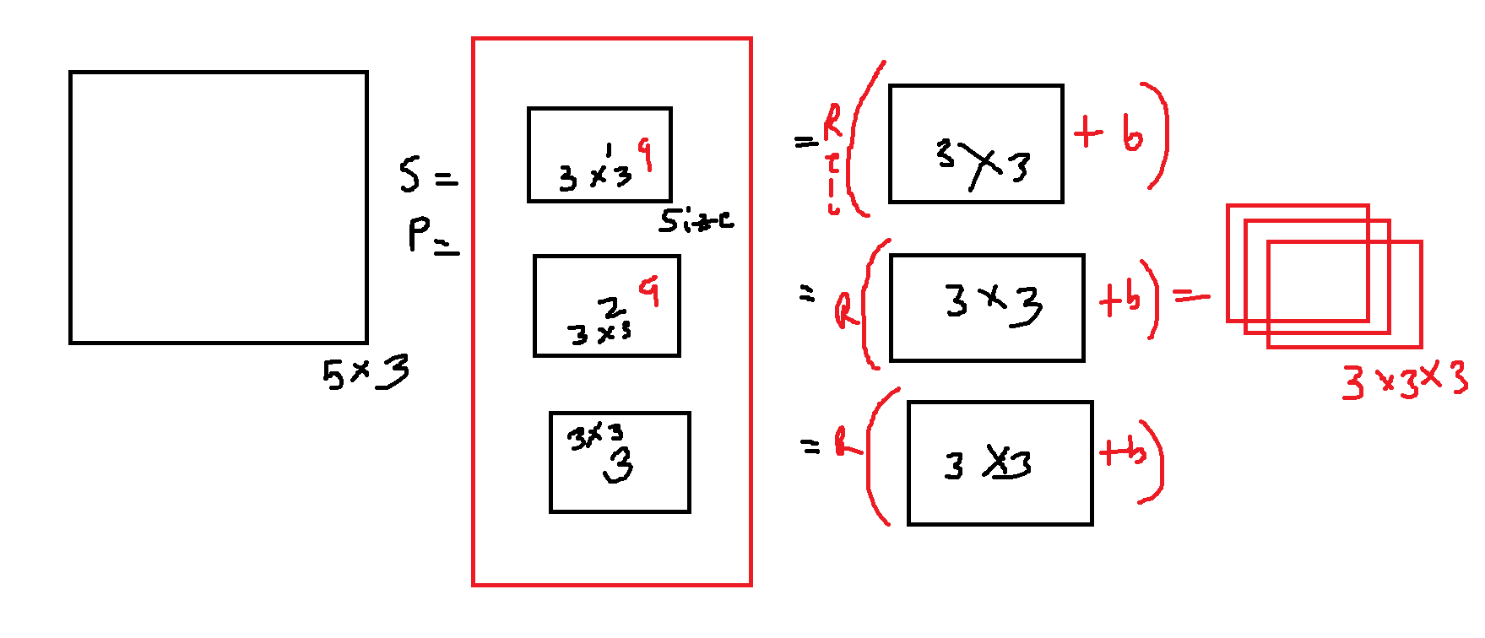
$$Parameters calculation$$

$$Assume that we have an image 512*512*3 \left(Color image\right)$$
$$Assume that our filter size=3*3=== >3*3*3$$
$$Number of filters=32$$

$$How many parameters=weights+bias$$
$$Step-1:Each filter has 3*3*3=27 weights$$
$$Step-2: we have 32 filters=32*27=864$$
$$Step-3:When we apply actiavation function on each feature map$$
$32 filters=32 bias$
$$Step-4:Total parameters=864+32=896$$

$$Shape:$$
$$Image multiply with filter , a feature map will generate it will pass through$$
$$Activation function finally we will get ouput$$
$$Number of filters=Number of outputs$$
$$In above example$$
$$\left(512*512*3\right) \left( 3*3*3\right)=Relu\left(510*510\right)=510*510$$
$$\left(512*512*3\right) \left( 3*3*3\right)=Relu\left(510*510\right)=510*510$$
$$\left(512*512*3\right) \left( 3*3*3\right)=Relu\left(510*510\right)=510*510$$
$$32 times==== >510*510*32$$

$$after Conv-1 layer we will apply pooling layer$$

$$Pooling:$$
$$Max pool$$
$the image divide by pool size , out of those values maximum will come$
$$Avg pool$$
$$the image divide by pool size , avg of all those values will come$$

$$Resultant image=8*8$$
$$Pooling size=2*2$$
$$Output image size=4*4$$

$$CNN :Object detection$$
$$Models are developed$$
$$VGG16$$
$$VGG32$$
$$mobile net$$
$$ResNet$$
$$RCNN$$
$$FasterRCNN$$
$$MASKRCNN$$
$$YOLO$$

$$In ML model we developed Logistic regression$$
$$save the mode=== .pkl or .joblib$$
$$In DL we trained one model$$
$$ANN.KERAS model.save(weights)$$

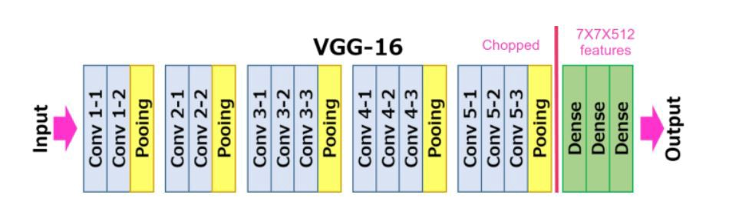

$$32*32 multiply image with 4*4=29*29$$
$$32*32*3 multiply image with 4*4*3=29*29$$

$$32*32 multiply image with 4*4 \left( we are using 3 filters\right)[4*4*3]=29*29*3$$
$$32*32*3 multiply image with 4*4*3 \left( we are using 3 filters\right)[4*4*3*3]=29*29*3$$

$$32*32 multiply image with 4*4 \left( we are using 3 filters\right)[4*4*3]=29*29*3$$

$$How many parameters are required?=4*4*3+3=51$$

$$32*32*3 multiply image with 4*4*3 \left( we are using 3 filters\right)[4*4*3*3]=29*29*3$$
$$How many parameters are required? 48*3+3=147$$

$$Finally One convolution layer$$
$$Original * Filter=== > Relu\left( Fmap+bias\right)=image$$
$$Padding , stride, Number of filters$$

$$Pooling layer:$$
$$Ones the image we got, Pooling layers$$
$$some times we feel Covolution result image also have many pixel values$$
$$we want to reduce that, from the all pixels we want identify important pixels$$
$$imortant pixels having the more information$$

- $Average pool$
$$For example : 6*6 , pooling layer:2*2$$
- $\max{pool}$

$$Convolution-layer1=OI*Filter=Relu\left(Feamap+bias\right)=Image$$
$$Inuput: Originalimage==> Convolution-layer1 + Pooling layer= Final image1$$
$$Inuput: Final image 1===>Convolution-layer2+Pooling layer=Final Image2$$
$$Inuput: Final image-2==>Convolution-layer3+Pooling layer=Final Image3$$
+
$$Final Image3:28*28=784 pixels falatten : Fully connected layer$$
$$Hidden layer$$
$$Output layer$$
$$Convolution Neural Netowrk$$

$$CNN is biggest development in DL$$
$$in ML we saved the model: Model.pkl file$$
$$in DL we can save the model: saving the weights$$
$$Our main goal: Find the suitable weights in order to reduce the error$$
$$weights file or parameter file$$
$$weights depends on model architecture$$
$$You can develop one good model, you save the weights$$
$$and share that weights to your friend , he will do the prediction===Transfer learning$$

$$we are not training the model from scratch, we will use already developed model weights$$
$$this is called Transfer learning$$

$$CNN====so many models$$

$$1)LeNet$$
$$2)AlexNet: Geffry Hinton GodFather of AI$$
$$3)VGG16 ,Vgg19,Vgg32$$
$$4) MobileNet$$
$$5) ResNet 50$$
$$6) RCN$$
$$7) fastRcnn$$
$$8) Mask Rcnn$$
$$9) Yolo$$

CNN python code
MobileNet code

$$Fine tuning is work$$
$$we will use those weights, and we will train the model on our data$$
$$we no need to worry about architecture$$
$$Directly take that model and pass the input output data$$
$$ask the model to learn$$

